Name: Sylvia Le

Course: COM219

**Homework 4**

Question 1

Let memory access time = t, hi = hit ratio

→ Cache L2 access time = 0.2 t

→ Cache L1 access time = 0.1t

During memory reference, L1 is searched, if fail the L2 is searched. If both L1 and L2 fail then main memory will be searched

Average access time will include success in cache L1, failure in L1 but success in L2, failure in L1 and 2 but success in memory

→ Average access time = h1 x 0.1t+ (1 – h1) x h2 x 0.2t + (1 – h1)(1 – h2) x 1 x t

= 0.8 x 0.1t + 0.2 x 0.9 x 0.2t + 0.2 x 0.1 x 1 x t

= 0.136t

**Ratio of main memory access time to system of two cache memory** = t/0.136t = 7.35

→ The memory access time is about 7.35 times slower without the cache system described above

Question 2

|  |  |  |  |
| --- | --- | --- | --- |
| **Type** | **Total effective disk size** | **Per TB cost of usable (effective) data storage** | **Fault tolerance** |
| RAID 0 | Data is distributed over every drives  → Effective disk size = 12x8 = 96 TB | Cost of 12 drives = 100 x 12 = $1200  Per TB cost = 1200/96 = $12.5 | Data is distributed  → Can’t lose any disk  → Fault tolerance = 0 |
| RAID 1 | Exact copy on all drives  → Effective disk size = 8 TB | Cost of 12 drives = 100 x 12 = $1200  Per TB cost = 1200/8 = $150 | Every drive keep the same copies  → Can lose up to 11 drives  → Fault tolerance = 11 |
| RAID 1+0 | Two groups of RAID 1 that together make up RAID 0  Each RAID 1 group has 12/2 = 6 drives  Each RAID 1 group capacity = 8 TB (as explained above)  → Effective disk size = 8 + 8 = 16 TB | Cost of 12 drives = 100 x 12 = $1200  Per TB cost = 1200/16 = $75 | Every drive in RAID 1 keep the same copies  → Each child can lose up to 6-1 = 5 drives  → Fault tolerance = 5x2 = 10 |
| RAID 100 | Two groups of RAID 1+0 that together make up RAID 0  Each RAID 1+0 group has 12/2 = 6 drives  Each RAID 1 group has 6/2 = 3 drives  Each RAID 1 group capacity = 8 TB (as explained above)  → Each RAID 1+0 group capacity = 8 + 8 = 16 TB  → Effective disk size: 16+16 = 32 TB | Cost of 12 drives = 100 x 12 = $1200  Per TB cost = 1200/32 = $37.5 | Every drive in RAID 1 keep the same copies  → Each child can lose up to 3-1 = 2 drives  → Fault tolerance = 2x2 = 4 |
| RAID 5 | Data is distributed but one drive is used for parity  → Effective disk size:  (12-1)x8 = 88 TB | Cost of 12 drives = 100 x 12 = $1200  Per TB cost = 1200/88 = $13.63 | One drive added for parity, but parity is distributed  → Fault tolerance = 1 |
| RAID 6 | Data is distributed but two drive is used for parity  → Effective disk size:  (12-2)x8 = 80 TB | Cost of 12 drives = 100 x 12 = $1200  Per TB cost = 1200/80 = $15 | Two drive added for parity, but parity is distributed  → Each child ault tolerance = 2 (the course note) |
| RAID 6+0 | Two groups of RAID 6 that together make up RAID 0  Each RAID 6 group has 12/2 = 6 drives  Each RAID 6 group capacity = (6-2)x8 = 32 TB (two drives for parity)  → Effective disk size = 32 + 32 = 64 TB | Cost of 12 drives = 100 x 12 = $1200  Per TB cost = 1200/64 = $18.75 | Each RAID 6 group has fault tolerance = 2 (the course note)  → Fault tolerance = 2 |

Question 3

Truth table:

|  |  |  |  |  |
| --- | --- | --- | --- | --- |
| **x** | **y** | **z** | **w** | **Out** |
| 0 | 0 | 0 | 0 | 0 |
| 0 | 0 | 0 | 1 | 0 |
| 0 | 0 | 1 | 0 | 0 |
| 0 | 0 | 1 | 1 | 0 |
| 0 | 1 | 0 | 0 | 0 |
| 0 | 1 | 0 | 1 | 0 |
| 0 | 1 | 1 | 0 | 0 |
| 0 | 1 | 1 | 1 | 0 |
| 1 | 0 | 0 | 0 | 1 |
| 1 | 0 | 0 | 1 | 0 |
| 1 | 0 | 1 | 0 | 1 |
| 1 | 0 | 1 | 1 | 0 |
| 1 | 1 | 0 | 0 | 1 |
| 1 | 1 | 0 | 1 | 0 |
| 1 | 1 | 1 | 0 | 1 |
| 1 | 1 | 1 | 1 | 0 |

1. The Boolean expression: consider the rows that has the output 1 (in red)

→ **f** = xy’z’w’ + xy’zw’ + xyz’w’ + xyzw’

1. The circuit for part (a):

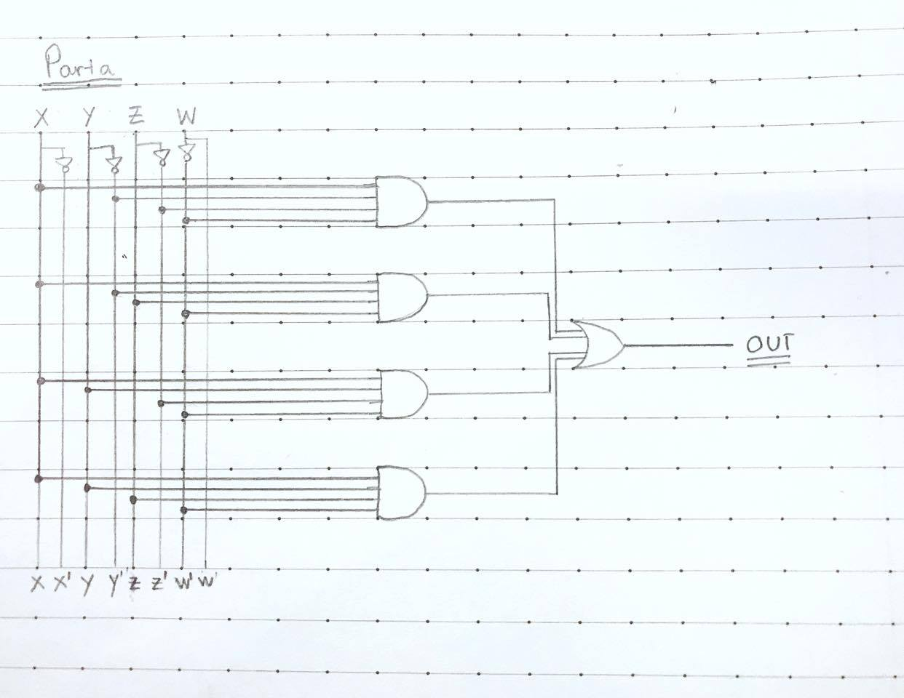

1. Simplification of part (a) **f**

**f** = xy’z’w’ + xy’zw’ + xyz’w’ + xyzw’

= xw’ (y’z’ + yz + y’z + yz’) //distributive law

= xw’ [y’(z’ + z) + y(z’ + z)] //distributive

= xw’[y’ + y] //inverse law, identity law

= xw’ //identity law

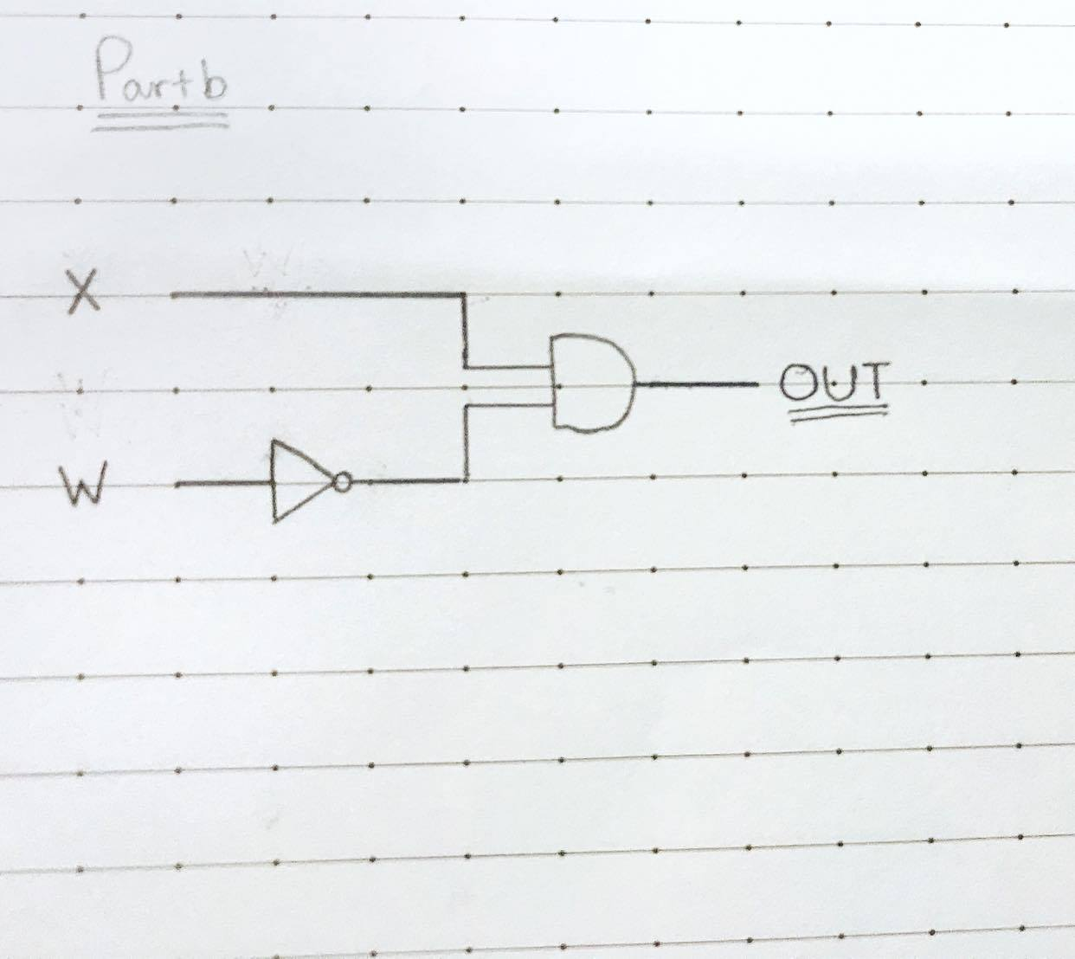

Question 4

1. Truth tables

* For part a: **f** = xy'z + xyz' + x'y' + xz'. Rows with output = 1 are

+ Rows that has the value of x, y, z of 101 or 110

+ Rows that has the value of x, y, z of 00* or 1*0 (* means it can be either value)

|  |  |  |  |  |
| --- | --- | --- | --- | --- |
| **x** | **y** | **z** | **Out** | **Check** |
| 0 | 0 | 0 | 1 | 1 |
| 0 | 0 | 1 | 1 | 1 |
| 0 | 1 | 0 | 0 | 0 |
| 0 | 1 | 1 | 0 | 0 |
| 1 | 0 | 0 | 1 | 1 |
| 1 | 0 | 1 | 1 | 1 |
| 1 | 1 | 0 | 1 | 1 |
| 1 | 1 | 1 | 0 | 0 |

* For part b: **f** = x’yz + y'z'w + x' (y'z' +y'zw') + y'zw = x’yz + y'z'w + x'y'z' + x’y'zw' + y'zw

Rows with output = 1 are:

+ Rows that has the value of x, y, z, w of 0010

+ Rows that has the value of x, y, z, w of 011*, *001, 000*, *011

|  |  |  |  |  |  |
| --- | --- | --- | --- | --- | --- |
| **x** | **y** | **z** | **w** | **Out** | **Check** |
| 0 | 0 | 0 | 0 | 1 | 1 |
| 0 | 0 | 0 | 1 | 1 | 1 |
| 0 | 0 | 1 | 0 | 1 | 1 |
| 0 | 0 | 1 | 1 | 1 | 1 |
| 0 | 1 | 0 | 0 | 0 | 0 |
| 0 | 1 | 0 | 1 | 0 | 0 |
| 0 | 1 | 1 | 0 | 1 | 1 |
| 0 | 1 | 1 | 1 | 1 | 1 |
| 1 | 0 | 0 | 0 | 0 | 0 |
| 1 | 0 | 0 | 1 | 1 | 1 |
| 1 | 0 | 1 | 0 | 0 | 0 |
| 1 | 0 | 1 | 1 | 1 | 1 |
| 1 | 1 | 0 | 0 | 0 | 0 |
| 1 | 1 | 0 | 1 | 0 | 0 |
| 1 | 1 | 1 | 0 | 0 | 0 |
| 1 | 1 | 1 | 1 | 0 | 0 |

1. Simplification:

* For part a:

**f** = xy'z + xyz' + x'y' + xz'

**=** (xyz’ + xz’) + (xy’z + x’y’) //commutative law

**=** [z’(x+xy)] + [y’(xz+x’)] //distributive law

**=** (z’x) + [y’(x’+z)] //absorption law (1st part), distributive law (2nd part)

= xz’ + [y’(x’+z)] //inverse law, identity law

**=** xz’ + x’y’ + y’z //distributive law

* For part b:

**f =** x’yz + y'z'w + x' (y'z' +y'zw') + y'zw

= x’yz + y’w(z+z’) + x’y’(z’+zw’) //commutative law, distributive law

= x’yz + y’w + x’y’(z+z’)(z’+w’) //inverse + identity law, distributive law

= x’yz + y’w + x’y’z’ + x’y’w’ //identity law, distributive law

= (y’w + x’y’w’) + x’yz + x’y’z’ //commutative law

= y’(w + x’w’) + x’yz + x’y’z’ //distributive law

= y’(w + w’)(w + x’) + x’yz + x’y’z’ //distributive law

= y’w + y’x’ + x’yz + x’y’z’ //identity law, distributive law

= (x’y’ + x’yz) + y’w + x’y’z’ //commutative law

= x’(y’ + yz) + y’w + x’y’z’ //distributive law

= x’y’ + x’z + y’w + x’y’z’ //(shortcut) distributive x 2, identity

= (x’z + x’y’z’) + x’y’ + y’w //commutative

= x’(z + y’z’) + x’y’ + y’w //distributive

= x’z + x’y’ + x’y’ + y’w //(shortcut) distributive x 2, identity

**=** x’z + x’y’ + y’w //indempotent law

1. Check: The column title **Check** above is added for this part

* For part a: rows with out put = 0 are rows that have value of x, y, x of 1*0, 00* and *01
* For part b: rows with out put = 0 are rows that have value of x, y, x, w of 0*1*, 00**, *0*1